BS2050 Thyroid Hormones

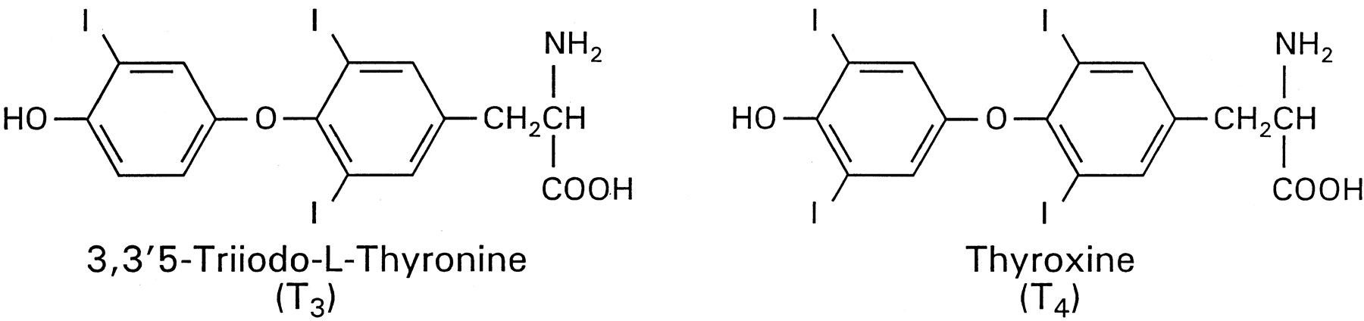The thyroid gland produces thyroxine (T4), tri-iodothyronine (T3) and calcitonin. T3 and T4 are referred to as the thyroid hormones and are important for normal growth and development and for energy metabolism whilst calcitonin is involved in the regulation of plasma Ca²⁺ levels. The actions of the hormones are very slow in comparison to most hormones, taking days to exert their effects. T3 is more biologically active than T4 and its effects are observed before those of T4 and it is believed that T4 is converted to T3 by an enzyme called deiodase whose function is to remove one of the iodine atoms before the thyroid hormone becomes active. Thus T4 is regarded as a pro-hormone, meaning that it is a hormone precursor.
Thyroid hormones produce a general increase in the metabolism of carbohydrates, fats and proteins, often by the modulation of the effects of other hormones such as insulin, glucagon, glucocorticoids and the catecholamine hormones. Thyroid hormones are thus often described as permissive hormones. The general effect of thyroid hormones are to cause an increased oxygen consumption and heat production, partly by increasing the turnover of ATP. This is manifested in a general increase in basal metabolic rate reflecting the action of the thyroid hormones on some organs such as the heart, kidney, liver, adipose tissue and muscle but not on others such as the gonads or spleen.
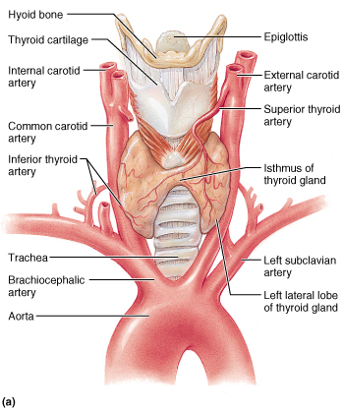
The thyroid gland is located in the neck in front of the trachea - the largest endocrine gland in the body. A cross section of the thyroid shows the Thyroid Follicles. Each follicle consists of a single layer of cuboidal epithelial cells surrounding a lumen, which contains colloid. The colloid can be specifically stained red with the periodic acid-Schiff method because of the chemical composition of colloid, which is a glycoprotein-iodine complex (thyroglobulin).

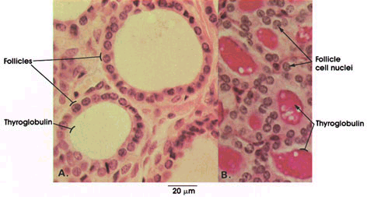

Synthesis of Thyroid Hormones

Thyroglobulin is synthesized in the thyroid epithelial cells and secreted into the lumen
Iodides (I–) are actively taken into the cell by the Na⁺/I⁻ symporter, oxidized by thyroid peroxidase and H₂O₂ and released into the lumen. Iodine is covalently attached to tyrosine, a reaction mediated by peroxidase enzymes, forming monoiodotyrosine, or MIT, di-iodotyrosine or DIT. Iodinated tyrosines are then linked together to form T₃ and T_{4.} Thyroid peroxidase catalyses the iodination of tyrosines on thyroglobulin (organification of iodide) and also the synthesis of thyroxine (or triiodothyronine) from two iodotyrosines. The thyroid hormones then accumulate in colloid as thyroglobulin.
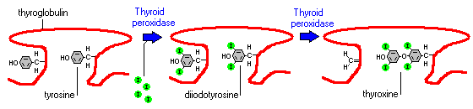
Iodinated thyroglobulin is thus stored as an extracellular storage glycoprotein in the colloid at the centre of the follicles. This is a most unusual method of storing a hormone or rather hormone precursor. Colloid is endocytosed from the apical surface of the thyroid follicular cells and combined with a lysosome, where T₃ and T₄ are enzymatically cleaved and diffuse into the bloodstream, once they have been produced there is no mechanism for their storage.
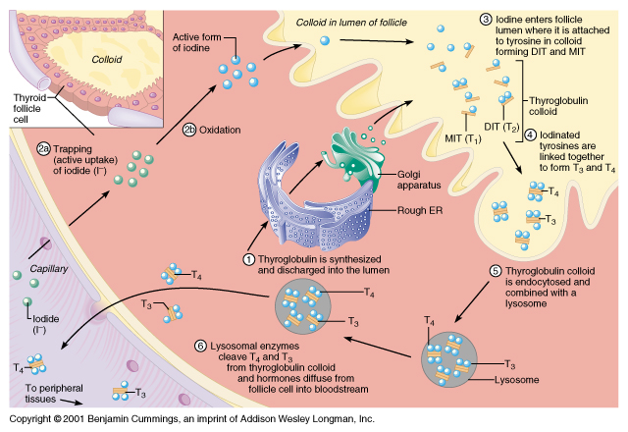

Transport of Thyroid Hormones

T₄ and T₃ are transported bound to thyroxine-binding globulins produced by the liver. There is ~50-fold more T₄ than T₃ in circulation but the ratio of free T₄ to T₃ is only about 3:1. Both bind to target cell receptors, but T₃ is ten times more active than T₄. Peripheral tissues have a de-iodase, an enzyme convert T₄ to the more activeT₃. The liver and kidney produce most of circulating T3 but it can also be produced locally when required e.g. in the pituitary. T₃ is thought to be the form of thyroid hormone which regulates the majority of cell functions

Mechanism of Action of Thyroid Hormone

Similar to steroid hormones except that nuclear thyroid receptors (TRs) are usually permanently associated with DNA at thyroid regulatory elements found in the promoter regions upstream of target genes. These are DNA sequences which bind to the receptor specifically with high affinity. TRs belong to a family of related receptors, including steroid receptors, which regulate specific gene transcription These can operate on their own to regulate gene transcription or they can interact with other receptors e.g. the retinoic acid (Vitamin A) receptor (RXR) to form dimers regulate gene transcription.

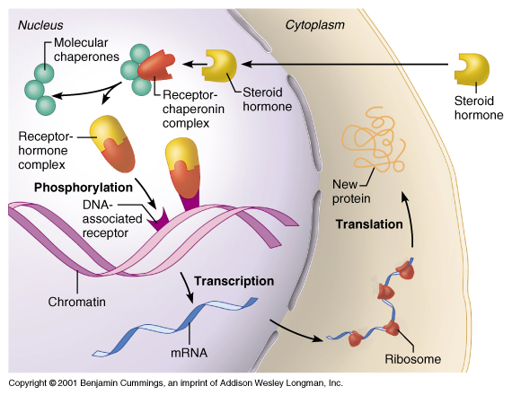
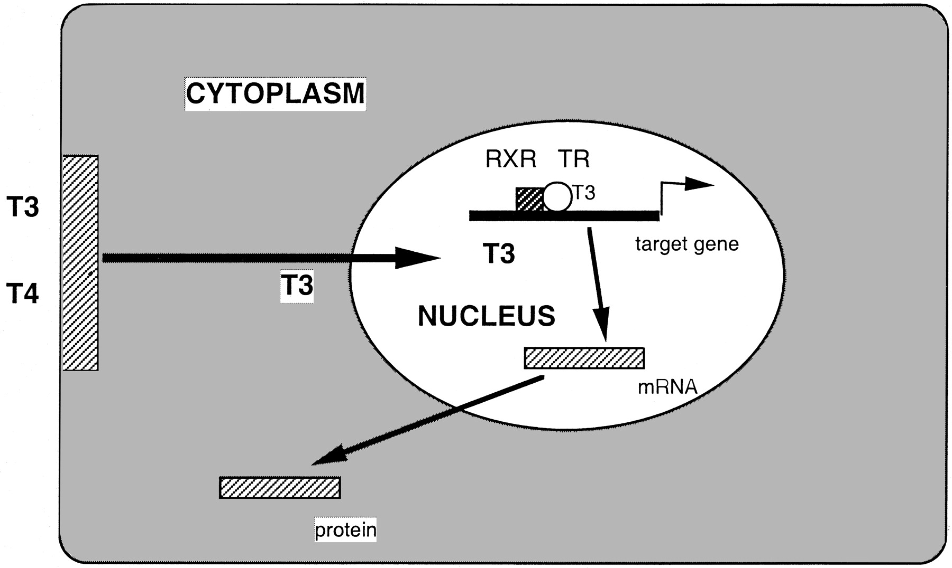

Physiological Effects of Thyroid Hormones (TH)

One of the most important main effects of thyroid hormone is to promotes normal oxygen consumption and basal metabolic rate (BMR) and as a result regulate body temperature by increasing calorigenesis. They also enhance the effects of the sympathetic nervous system e.g increased sensitivity to adrenaline. In the hypothyroid condition the BMR is reduced, the body temperature is lowered, there is decreased appetite but weight gain and reduced sensitivity to adrenaline.

TH are critical for normal growth and development of bones particularly in young children where hypothyroidism results in short stature. TH regulates specific protein synthesis in osteoclasts and osteoblasts which are essential for the growth and remodelling of bone in development. TH also stimulate Growth Hormone and Insulin-Like Growth Factor secretion. TH are also important in normal cardiovascular function: they regulate total protein synthesis in the heart and also the transcription of specific proteins such as the myosin heavy chain genes. TH increase cardiac output, cardiac muscle mass and increase blood volume. Hypothyroid patients have low cardiac output, decreased stroke volume, decreased blood volume and increased vascular resistance.

TH regulate many aspects of carbohydrate, fat and protein metabolism in liver and adipose tissue. In the liver TH increase glucose catabolism to generate ATP and also increases fat mobilization, breakdown and synthesis. TH are essential for normal protein synthesis.Use of cDNA microarray technology has recently shown that 55 genes in liver are regulated by TH - 14 positively regulated and 41 repressed. TH play an important role in the development if both brown and white adipose tissue for example the differentiation of white adipose tissue from pre-adipocytes. TH induce mitochondrial uncoupling proteins in brown adipose tissue - these are important in thermogenesis

TH are important for normal brain and CNS function. They are essential for the normal development of the foetal brain and also in the neonatal period, hypothyroidism at this stage leads to mental retardation and neurological defects (cretinism). In adults hypothyroidism (myxoedema) leads to mental impairment including: slow reflexes, slow speech with deep hoarse voice and general lethargy. Recent studies with hypothyroid neonatal rats show reduced axonal growth and dentritic branching in many areas of the brain, including cerebral cortex, visual and auditory cortex, hippocampus and cerebellum.

TH regulate the synthesis and secretion of a number of different pituitary hormones for example T3 stimulates the transcription of the gene coding for Growth Hormone and negatively regulates transcription of both subunits of TSH (part of the negative feedback regulation of thyroid hormone secretion)

There is also evidence for a role of TH in development of erythrocytes and leukocytes (haematopoiesis). TH promote gastrointestinal motility and tone and increase secretion of digestive juices. They have effects on normal muscular development and function and on female reproductive capacity and lactation. In other words, there is hardly a cell, tissue or organ in the mammalian body which is unaffected by thyroid hormones!

Regulation of Thyroid Hormone Release

TH synthesis (and secretion is tightly regulated by a negative feedback system that involves the hypothalamus , pituitary and the thyroid gland – the so-called Hypothalamic/Piuitary/Thyroid axis. Thyrotropin-releasing hormone (TRH) is synthesised in the para-ventricular nucleus of the hypothalamus, released into the portal capillary plexus transported to the thyrotrope cells in the anterior pituitary where it binds to receptors and initiates the release of TSH.

TSH is a 28 kDa glycoprotein hormone made up of α and β subunits, both essential for activity but it is the β subunit which confers specificity. The α subunits are common to other hormones such as FSH and LH but the β subunit is unique to TSH. TSH binds to receptors on thyroid epithelial cells and causes thyroid hormone to be synthesised and secreted. TSH stimulates the transcription of a number of specific genes coding for important proteins in the thyroid epithelial cells, notably: the Na⁺/I⁻ Symporter (NIS) which concentrates iodide into the thyroid, Thyroglobulin and Thyroid peroxidase (TPO). TSH secretion is also subject to feedback inhibition by thyroid hormones and this probably involves the conversion of T4 → T3 by a pituitary deiodase and the binding of T3 to the receptor, which inhibits transcription of the β subunit.

TSH exerts its effects by binding to a transmembrane receptor in the thyroid follocle epithelia and increasing intracellular cAMP which acts as second messenger. In the hyperthyroid condition, Graves Disease, the receptor is simulated by autoantibodies causing increased thyroid hormone secretion. Hyperthyroidism (thyrotoxicosis), results in high metabolic rate, high temperature, tachycardia, hyperactivity, and increased appetite associated with weight loss. See Lab. notes for treatment.
Hypothalamus
Negative Feedback loop regulating the hypothalamic/pituitary/thyroid axis

TRH

Anterior Pituitary

Thyroid Follicles
TSH
T3 + T4
References:
Marieb E.N. (2004) Human Anatomy and Physiology (6th ed Chapter 16 The Endocrine System
Yen P M (2001) Physiol. Reviews. 81, 1097

